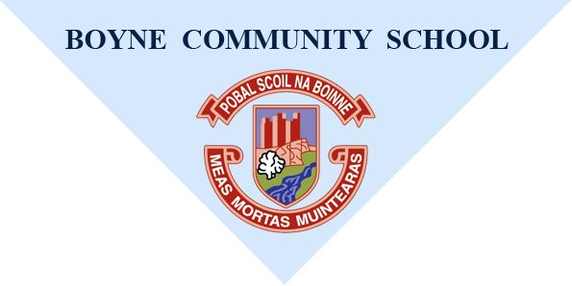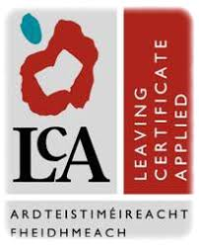
2025/2026

Name______________ Class: _______________
Why do you want to do the Leaving Certificate Applied Course?
........................................................................................................................................................................
……………………………………………………………...............................................................................................
What career do you wish to take up when you leave school?
………………………………………………………………
………………………………………………………………

Are you prepared to do the following? Circle Please
• Have 90% attendance for each subject module: Yes No
• Complete four Key Assignments
(minimum) for each module: Yes /No
• Complete seven "Tasks": Yes/ No
• Meet all deadlines for Key Assignments
and Tasks as set by individual teachers and
The Department of Education: Yes/No
• Behave appropriately in school and for
all out of school activities: Yes /No
• Complete all homework on time: Ye/ No
• Wear the full school uniform every day: Yes /No
• Bring all necessary equipment, books, resource materials
(e.g. ingredients for Hotel Catering and Tourism)
to class every day. Yes /No
• Co-operate with your classmates in the use of
shared facilities (e.g. tools or stationery): Yes /No
• Take full responsibility for arriving to school
on time and likewise to every class on time: Yes /No
• Be co-operative, courteous, friendly and adult-like
in your relationships with your teachers and fellow
classmates: Yes /No

How do you think your behavior has helped or hindered your progress in Boyne CS?
……………………………………………………………………………………………………………………………………………………………………………………………………………………………………………………………………………………………………………………………………………………………………………………………………………………………………………………………………………..

What hobbies or interests do you have?
…………………………………………………………………………………………………………………………………………………………………………………………………………………………………………………………………………………
Where would you like to go on work experience? - please state why
……………………………………………………………………………………………………………………………………………………………………………………………………………………………………………………………………………………
What do you hope to gain by doing Leaving Certificate Applied - how do you hope the course will help you (e.g. academically, new skills, personal development, work experience, friends, career decision, etc.)?
………………………………………………………………………………………………………………………………………………………………………………………………………………………………………………………………………………………………………………………………………………………………………………………………………………………………………………………………………
Student’s signature: ……………………………….
Signature of parent/guardian: ……………………………….
Please note:
This form is one part of the selection process for Leaving Certificate Applied which also includes interviewing prospective candidates. Completion of this form is not a guarantee of acceptance on the course.
Closing date for return of application forms Wednesday 18th December 2024

