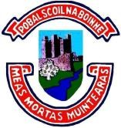
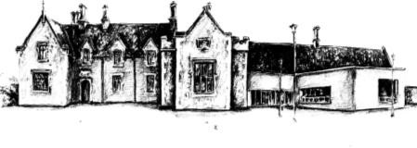
POBALSCOIL NA BÓINNE BOYNE COMMUNITY SCHOOL
Trim, Co. Meath. C15RK79
Charity Registered No.: 20204530

22/09/2023
Dear Parent(s)/Guardian(s),

As a parent of a student in LCA 2, I am writing to inform you of the upcoming task due for completion by your son/daughter.

The Practical Achievement Task is due for completion by December 2023 and assessment interviews will take place in early January 2024. The main responsibility for this task rests with the individual student. The task requires the student to learn a new skill or complete a short course. Each student should complete the work/activity related to the achievement in their own time. This should be for a minimum of six to ten hours. A qualified instructor/mentor will be required to sign off on the student’s task and a report booklet will be completed during class time. This task is worth up to ten credits and therefore is a substantial piece which should be treated accordingly.

I have outlined the details of the task to students and I will support and guide them through the completion of this task. That said it is the student who is responsible for the completion of the task, the submission of the report booklet and their performance in the interview.

If you have any further queries please do not hesitate to contact me by phone or email aharrington@boynecs.ie

Kind Regards,
Ms Harrington

Jean Ryan | � 046/9481654 - Fax - 0469481660 | Donncha Ó Siadhail
PRINCIPAL  www.boynecs.com | email address: info@boynecs.ie Feargal Flanagan  DEPUTY PRINCIPALS | Fergal O’Callaghan

