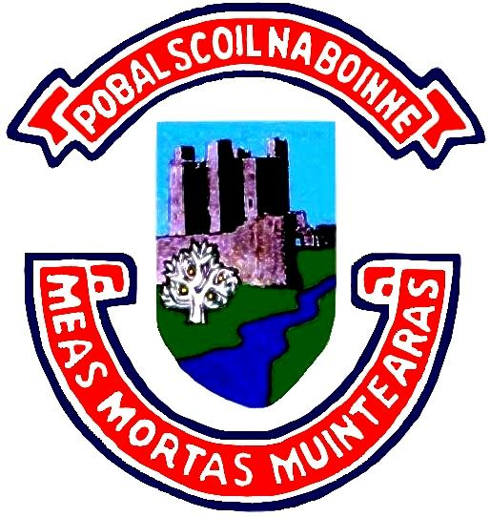
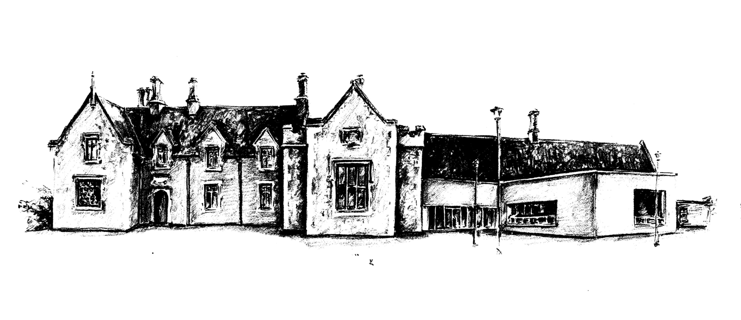
POBALSCOIL NA BÓINNE
BOYNE COMMUNITY SCHOOL
Trim,
Co. Meath.
C15RK79
Charity Registered No.: 20204530

31st of May 2022

School Fees

Dear Parent/Guardian,

The School contribution fee is €100 for 1 Student and €150 for more than 1 student (School Family Contribution). This fee includes student insurance, photocopying, printing, web text, telephone and sundry expenses. This is available for payment on the school’s payment system, Easy Payments Plus. This fee can be paid in full or in installments.

Our Book Rental Scheme is now available for all students. This is also available for payment on Easy Payments Plus. The cost of the book rental is €120 which includes all books, workbooks and the school journal. The fee can be paid in full.

There is also a fee for the practical subjects. The subjects involving fees are Home Economics,
Engineering, Wood Technology/ Construction Studies and Graphics/ Design & Communication Graphics. The fee per subject is €40.

This fee must be paid for each practical subject that your son/daughter studies. These fees are available on the school’s payment system, Easy Payments Plus for payment. As the costs involved in these subjects have increased dramatically in the past year students who have not paid the fee will be unable to participate in practical classes.

As the student population has grown considerably in the last few years we are not in a position to issue lockers to all students. Students who wish to avail of a locker must sign up. We will send out a text with further details in the coming weeks. Lockers will be issued on a first come first served basis.

Yours sincerely

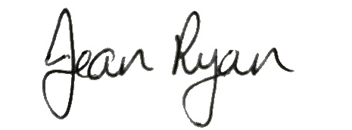
Jean Ryan
PRINCIPAL

